I have created a UI for the Shre Kundodhari Cement Products. - I want to make that website live so that the admin can log in and use it daily. As I created in UI, what are the next steps that I need to take so that it can be a production website really used on a daily basis? ex: Admin wants to add customer.
That’s a great milestone, Harish — you’ve already built the UI for Shree Kundodari Cement Products, which means you’re halfway to production. Now it’s time to make it live, secure, and functional so your admin can log in, add customers, and manage operations daily.
Here’s a clear roadmap 👇
🧩 1. Backend Setup (Core Functionality)
Your UI needs a backend to handle data and authentication.
🔹 Choose a Backend Stack
Since your UI is in React/TypeScript:
- Node.js + Express → perfect for REST APIs.
- Database → PostgreSQL or MongoDB (for structured vs flexible data).
- ORM → Prisma or Mongoose for easier data modeling.
🔹 Key Backend Features
Feature | Description
Authentication | JWT-based login for admin and users.
Customer Management | CRUD APIs (Create, Read, Update, Delete) for customers.
Inventory & Production | APIs to track cement blocks, raw materials, and daily production.
Payments | Endpoints for vendor/customer transactions.
Labour Management | APIs for check-in/out, wages, and timesheets.
🧱 2. Database Design
Create tables/collections for:
- users (admin, staff)
- customers
- inventory
- production
- payments
- labours
- orders
- dispatch
Each should have timestamps (createdAt, updatedAt) and unique IDs.
🔐 3. Authentication & Authorization
- Use JWT for secure login sessions.
- Store passwords hashed (e.g., bcrypt).
- Restrict access: only admin can add/edit customers, staff can view/update limited data.
🚀 4. Deployment
Frontend
- You already use Vercel — keep it for your React app.
Backend
- Deploy your Node.js API on:
  - Render, Railway, or Vercel Functions (for small projects)
  - AWS, Azure, or Google Cloud (for enterprise scale)
Database
- Use Neon, Supabase, or MongoDB Atlas for managed cloud databases.
⚙️ 5. Connect Frontend + Backend
- In your React app, replace mock data with real API calls using axios or fetch.
- Example:
tsx
const response = await axios.post("/api/customers", { name, contact });
- Use environment variables for API URLs:
Code
REACT_APP_API_URL=https://your-backend-url.com
🧑‍💼 6. Admin Dashboard Features
Once live, the admin should be able to:
- Log in securely.
- Add/edit/delete customers.
- View production stats and payments.
- Manage labour attendance and wages.
- Track dispatch workflow (Confirmed → Delivered).
- View analytics charts (using Chart.js or Recharts).
🧰 7. Production Hardening
- Enable HTTPS (Vercel does this automatically).
- Add error logging (e.g., Sentry).
- Use rate limiting and validation (e.g., express-validator).
- Set up daily database backups.
🧠 8. Optional Enhancements
- Role-based access (Admin, HR, Sales).
- Email notifications for new orders.
- Export reports (CSV/PDF).
- Integrate calendar with Indian holidays for scheduling.
✅ Summary
You already have:
- ✅ UI (React) You need to add:
- 🔧 Backend (Node.js + Express)
- 🗄️ Database (PostgreSQL/MongoDB)
- 🔐 Authentication (JWT)
- 🚀 Deployment (Vercel + Render)
- 🧑‍💼 Admin dashboard integration
Would you like me to outline the backend folder structure and API endpoints (like /api/customers, /api/login, /api/payments) next? That’ll make your transition from UI to production much smoother.
=-=-=
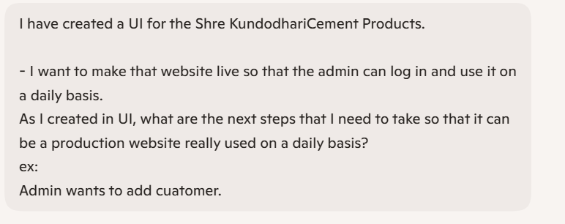
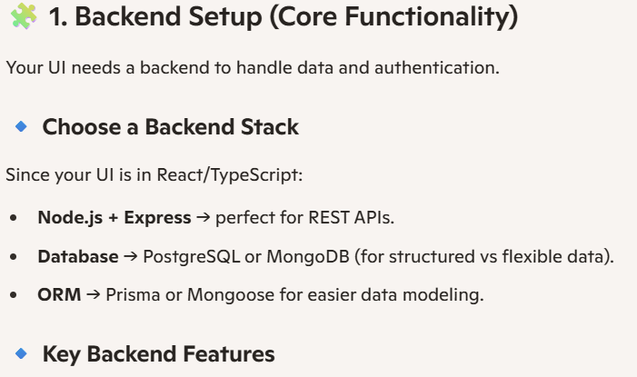
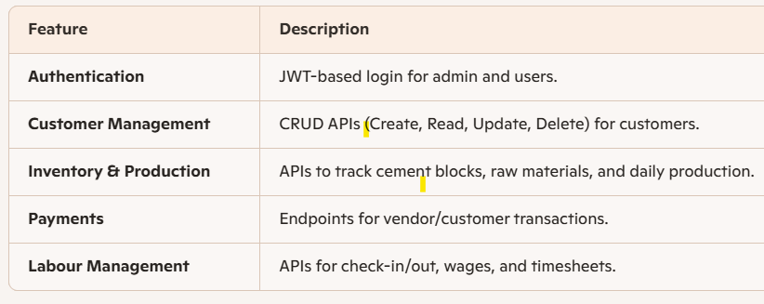
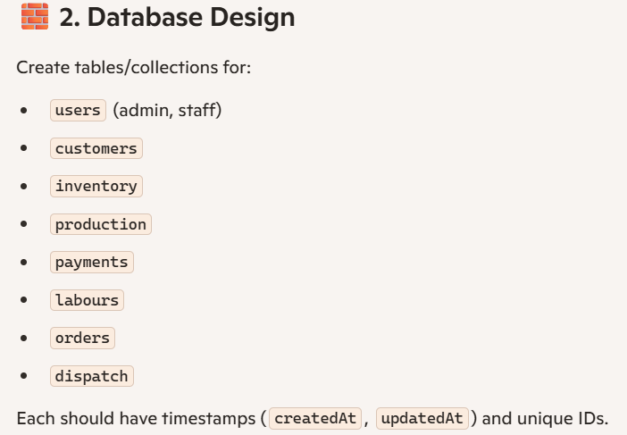
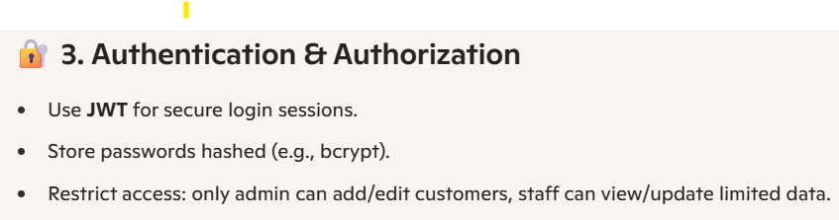
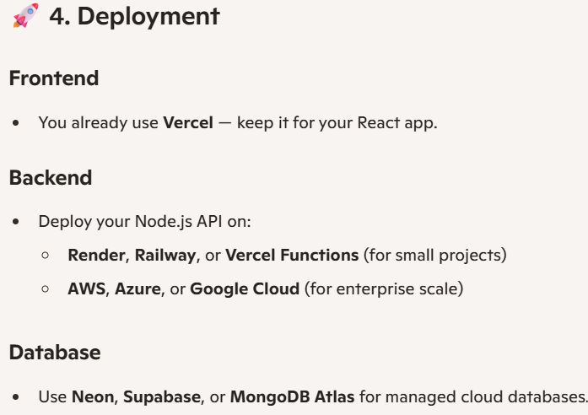
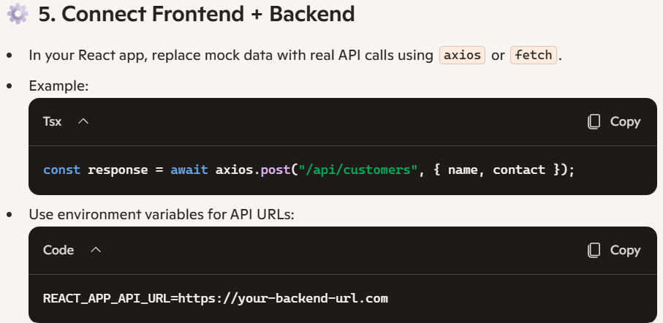
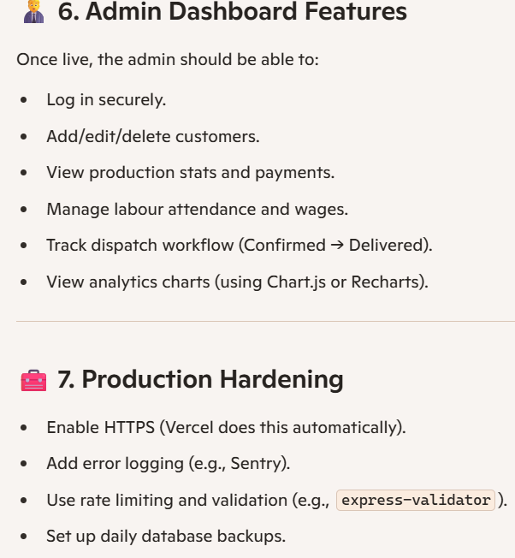
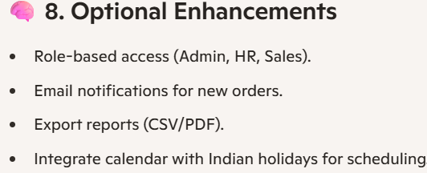
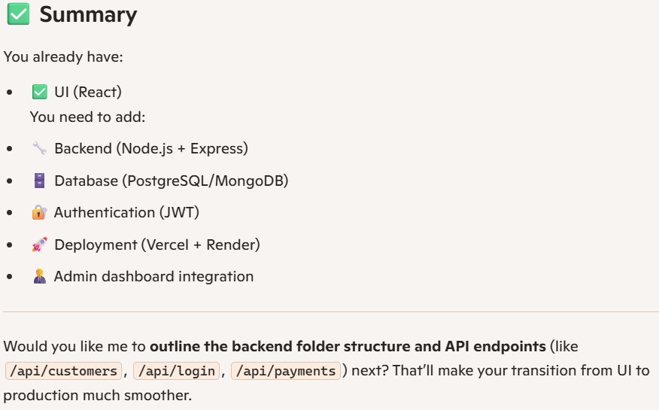
=completed=
Recommended Folder Structure (Backend + Frontend)
Here’s a clean Node.js + Express + React setup:
shree-kundodari-cement-products/
│
├── backend/ # Node.js + Express API
│ ├── src/
│ │ ├── config/ # DB connection, environment configs
│ │ ├── controllers/ # Business logic (e.g., customerController.js)
│ │ ├── models/ # Database schemas (e.g., Customer.js, User.js)
│ │ ├── routes/ # API routes (e.g., customerRoutes.js)
│ │ ├── middleware/ # Auth, validation, error handling
│ │ └── server.js # Express app entry point
│ ├── package.json
│ └── .env # Secrets (DB URL, JWT secret)
│
├── frontend/ # React + TypeScript UI
│ ├── public/ # Static assets (logo, favicon)
│ ├── src/
│ │ ├── components/ # Reusable UI blocks (Sidebar, Header, Forms)
│ │ ├── pages/ # Dashboard pages (Inventory, Customers, Payments)
│ │ ├── services/ # API calls (axios/fetch)
│ │ ├── context/ # Auth context, theme context
│ │ └── App.tsx
│ ├── package.json
│ └── .env # API base URL
│
├── database/ # SQL scripts or migrations
│ └── schema.sql
│
└── README.md
=-=-=-=-=-=-=-=-=-=-=-=-=-=-=-=-=-=-=-=-=-=-=-
Example API Endpoints
- POST /api/auth/login → Admin login
- POST /api/customers → Add customer
- GET /api/customers → List customers
- PUT /api/customers/:id → Update customer
- DELETE /api/customers/:id → Remove customer
- GET /api/inventory → Cement blocks, raw materials
- POST /api/payments → Record payment (QR, card, cash, etc.)
- GET /api/dispatch → Track workflow (Confirmed → Delivered)
=-=-=-=-=-=-=-=-=-=-=-=-=-=-=-=-=-=-=-=-=-=-=-=-=-=-=-=-=
Can This Be Done for Free?
Yes — for a small-scale project, you can integrate frontend + backend + database without paying:
- Frontend (React UI) → Free hosting on Vercel or Netlify.
- Backend (Node.js/Express) → Free hosting on Render, Railway, or Vercel Functions.
- Database:
  - Supabase (Postgres) → free tier.
  - MongoDB Atlas → free tier.
  - Neon (Postgres serverless) → free tier.
- Auth → Free with JWT (no external cost).
- Version Control → GitHub free.
- Domain → Optional. You can use the free Vercel URL (.vercel.app) or buy a custom domain later.
⚠️ Limits: Free tiers usually have usage caps (e.g., database rows, monthly requests). For daily admin use with moderate data, free tiers are fine. If you scale to hundreds of users, you’ll eventually need paid plans.
-=-=-=-=-=-=-=-=-=-=-=-=-=-=-=-=-=-=-=-=-=-=-=-=-=-=-=-=-=-=-=-=
✅ Summary
- You can deploy your UI + backend + database for free using Vercel + Render + Supabase/MongoDB Atlas.
- The folder structure above keeps things organized.
- Start with free tiers, and only upgrade if your usage grows.
=-=-=-=-=-=-=-=-=-=-=-=-=-=-=-=-=-=-=-=-=-=-=-=-=

